ACLRS — Laboratory Management Report Module Test

Laboratory Management Report
Tester | KIM NGAN LE
Date | 25/09/2026
Module | Laboratory Management Report Portal
Testing Tool | Selenium WebDriver
Web Browser | Google

Test Case Summary
Test ID | Tool | Test Result | Comment
TC-LAB-01 | Selenium WebDriver | PASS | Initial automated login test did not successfully complete the required authentication. Selenium authentication sequence was reviewed to correctly handle login, MFA verification and Laboratory Manager role selection.
TC-LAB-02 | Selenium WebDriver | PASS
TC-LAB-03 | Selenium WebDriver | PASS | Selenium expected the KPI text “Average TAT”, while the implemented interface uses “Avg Turnaround”. Test assertion was updated to match the actual KPI label implemented in the portal.
TC-LAB-04 | Selenium WebDriver | PASS
TC-LAB-05 | Selenium WebDriver | PASS
TC-LAB-06 | Selenium WebDriver | PASS
TC-LAB-07 | Selenium WebDriver | PASS | Selenium initially failed to reliably retrieve and validate the displayed report-table column text. Table validation was changed to retrieve the rendered “textContent” of the table headers.
TC-LAB-08 | Selenium WebDriver | PASS | Selenium returned an “element click intercepted” exception when attempting to click the Search control. The automated interaction was changed to submit the report search form reliably rather than depending on the intercepted screen click.
TC-LAB-09 | Selenium WebDriver | PASS | Selenium initially failed to reliably validate the displayed Staff Workload column headings. Header validation was changed to retrieve the rendered “textContent” from the workload table.
TC-LAB-10 | Selenium WebDriver | PASS
TC-LAB-11 | Selenium WebDriver | PASS
TC-LAB-12 | Selenium WebDriver | PASS

Evidences:
- TC-LAB-01 – Fail
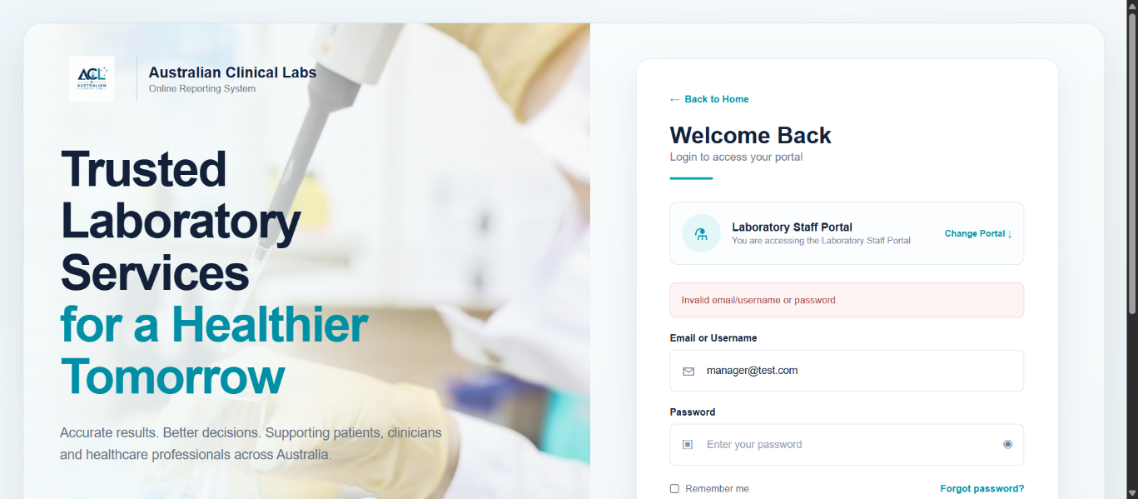
- TC-LAB-01 – Pass
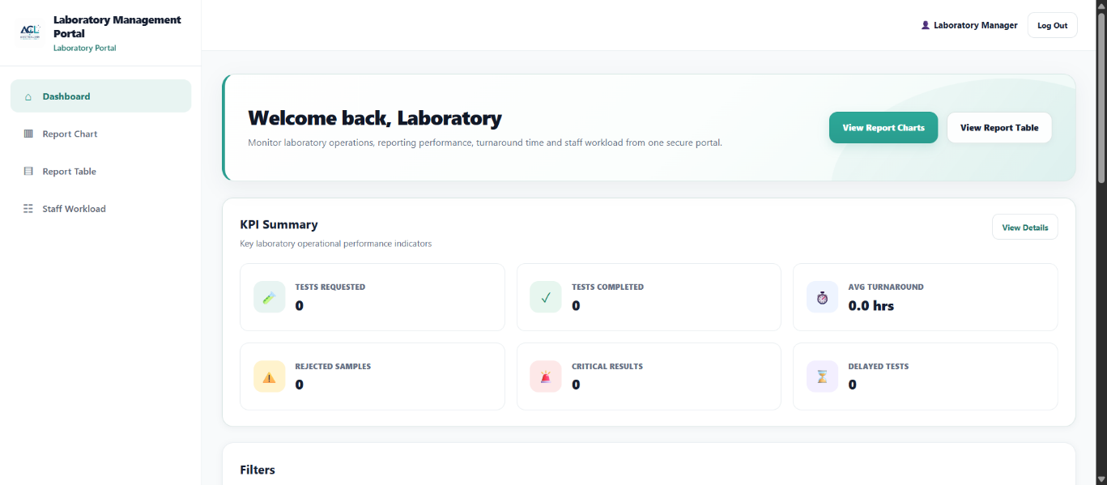
- TC-LAB-02
- TC-LAB-03 -Fail
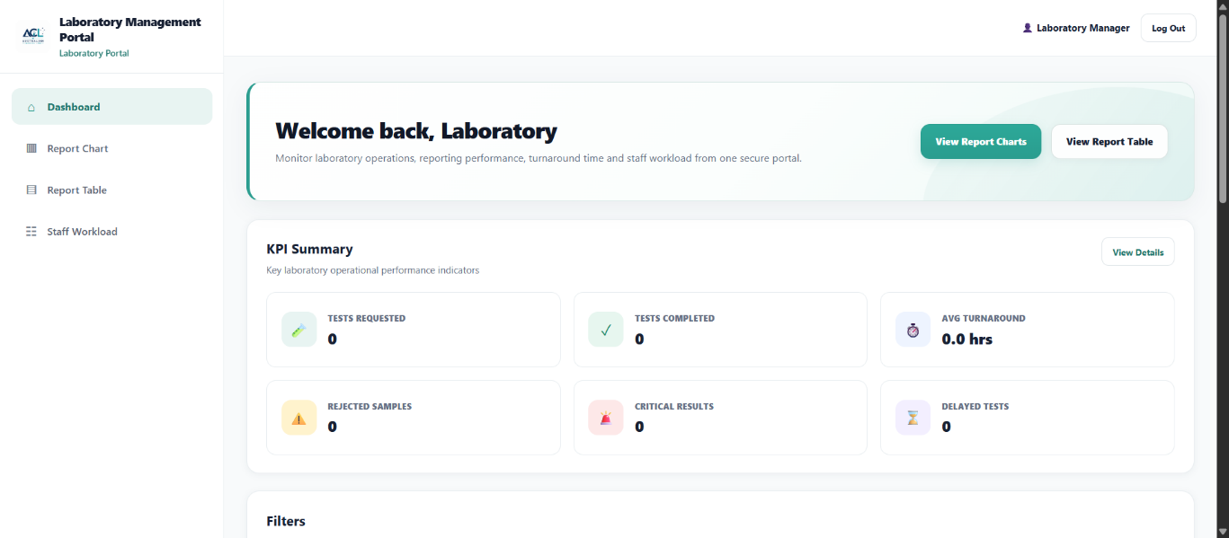
- TC-LAB-03 -Pass
- TC-LAB-04
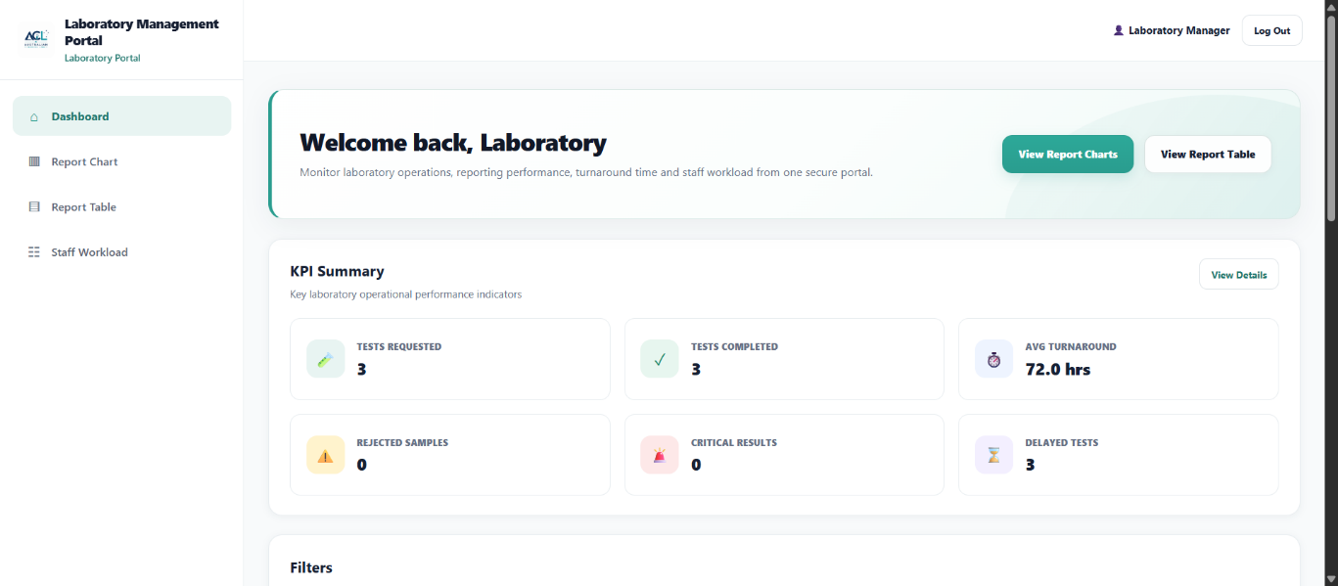
- TC-LAB-05
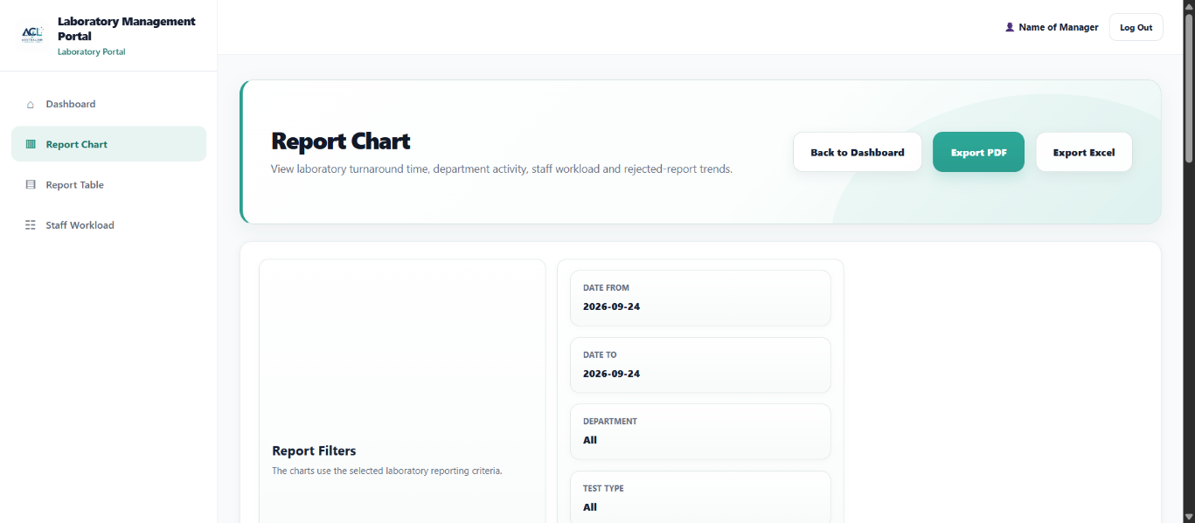
- TC-LAB-06
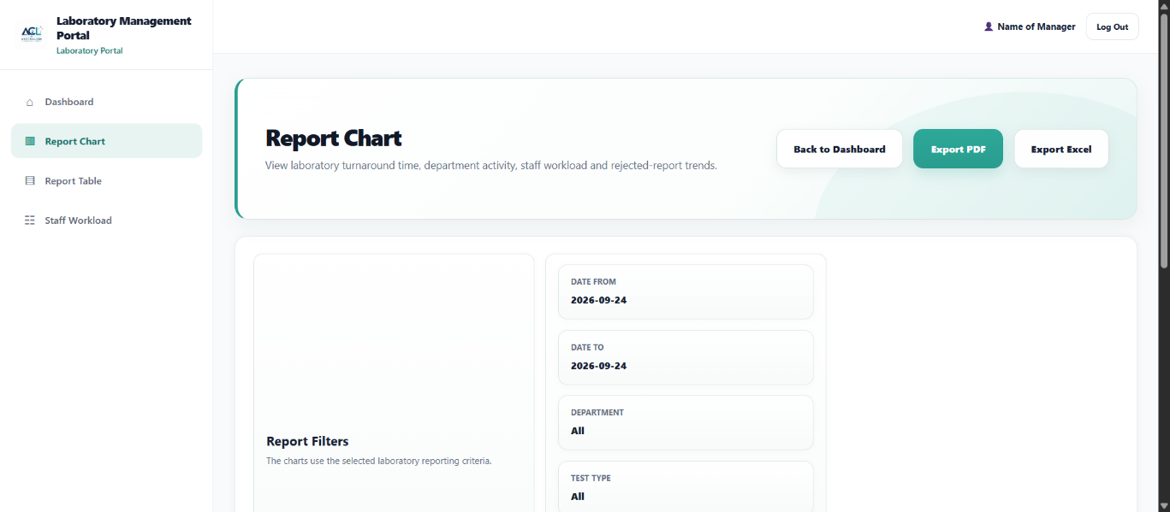
- TC-LAB-07 – Fail
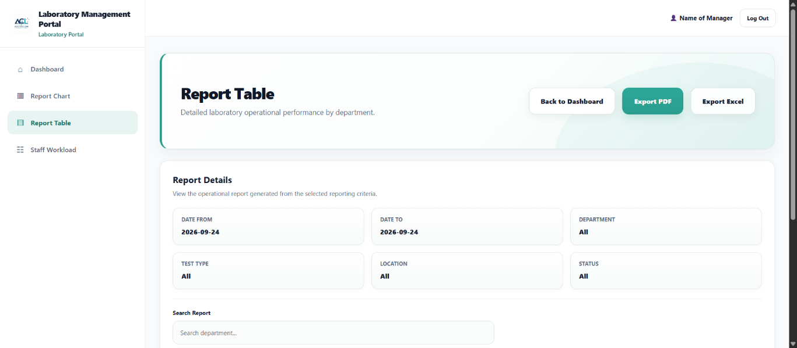
- TC-LAB-07 – Pass
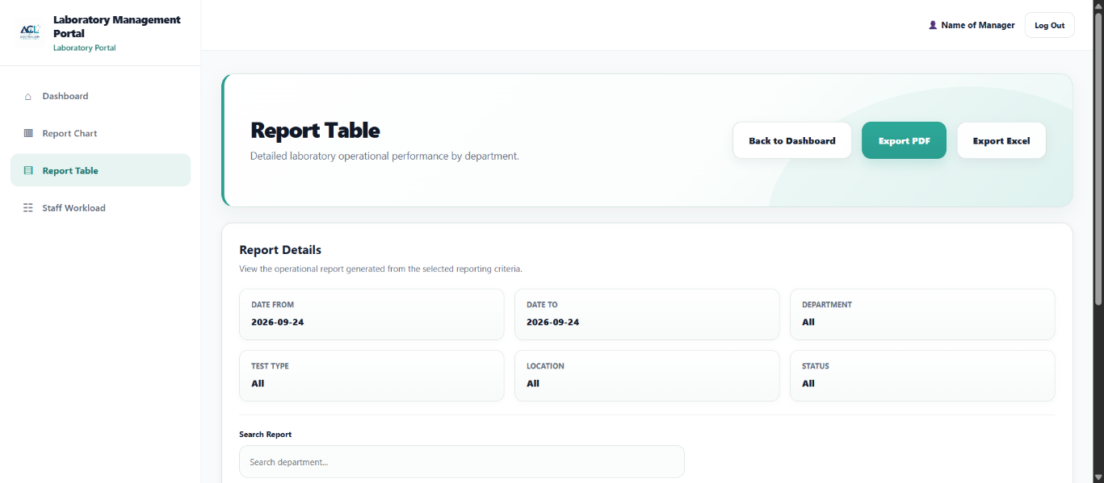
- TC-LAB-08 – Fail
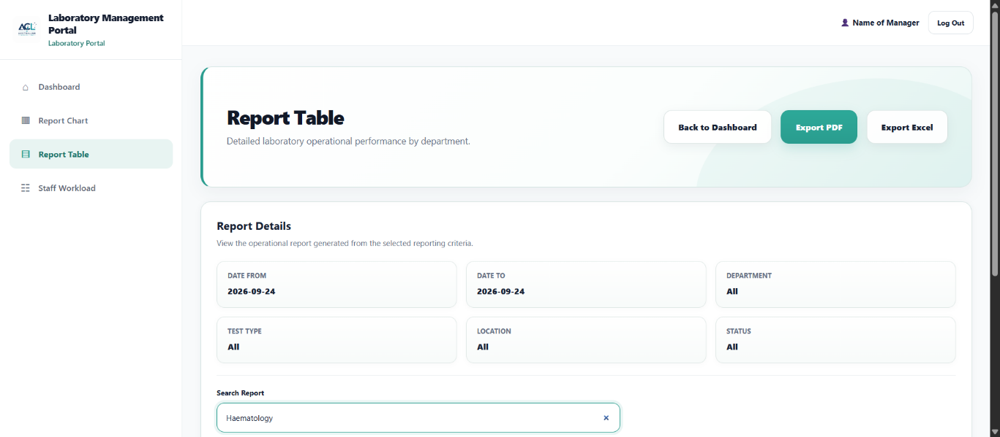
- TC-LAB-08 – Pass
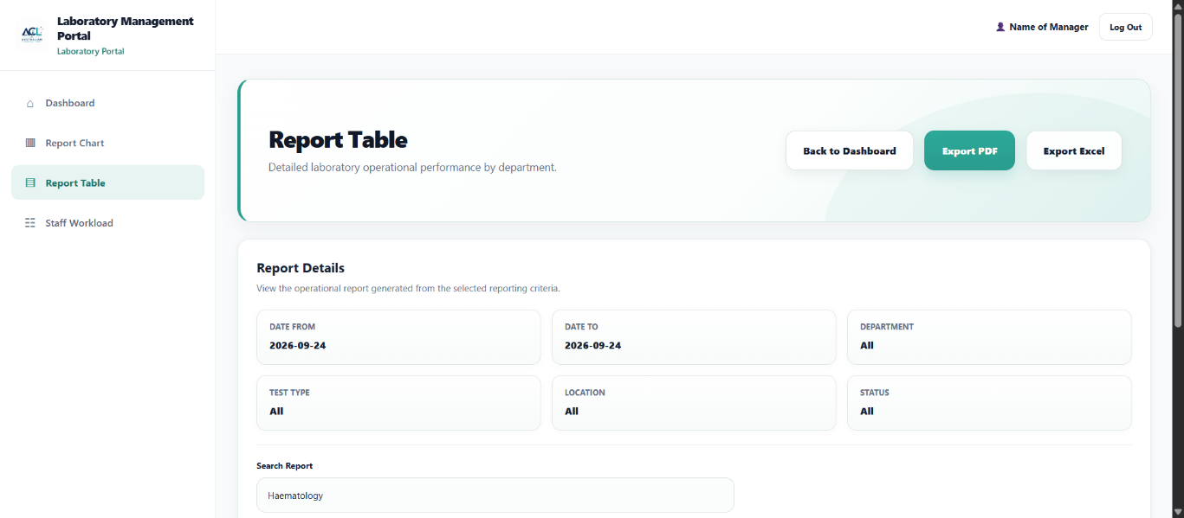
- TC-LAB-09 – Fail
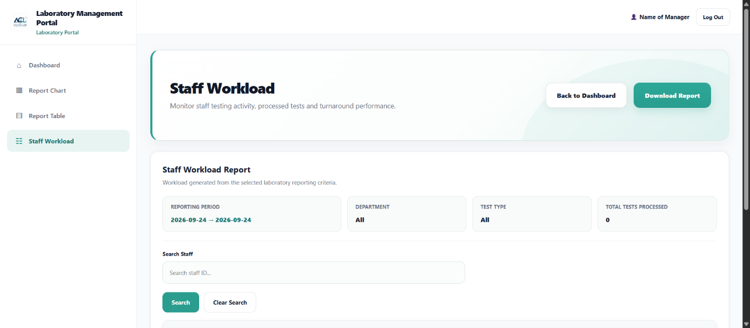
- TC-LAB-09 – Pass
- TC-LAB-10
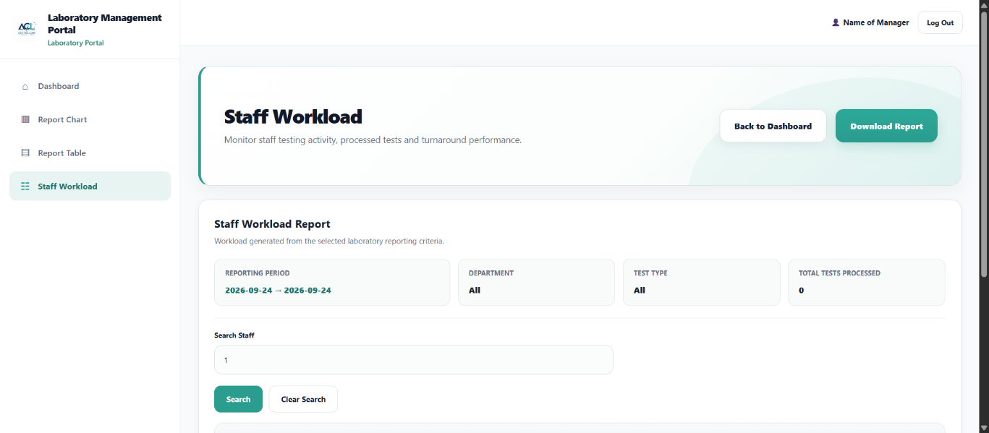
- TC-LAB-11
- TC-LAB-12

